Criar o service localStorageSrv.js

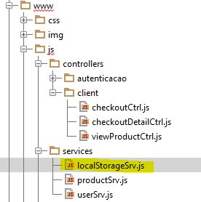

Chamar na Index.html

<**script src="js/services/localStorageSrv.js"**></**script**>

Criar Dois Métodos o set e o get somente para dados

**angular**.module(**'starter.services'**).**factory**(**'$localStorage'**, [**'$window'**, **function** ($window) {  
 **return** {  
 *//SÓ PARA DA PURO E NAO OBJETO* **set**: **function**(key, value) {  
 $window.**localStorage**[key] = value;  
 **return** $window.**localStorage**[key];  
 },  
 *//SÓ PARA DA PURO E NAO OBJETO* **get**: **function**(key, defaultValue) {  
 **return** $window.**localStorage**[key] || defaultValue;  
 }  
 }  
}]);

Setar o valor no viewProductCtrl.js

**angular**.module(**'starter.controllers'**).**controller**(**'ClientViewProductCtrl'**,[  
 **'$scope'**, **'$state'**, **'Product'**, **'$ionicLoading'**, **'cart'**, **'$localStorage'**,  
 **function** ($scope, $state, Product, $ionicLoading, cart, $localStorage) {  
  
 ***console***.log($localStorage.set(**'cart'**, **'meu dado'**));

Pegar o valor cart checkoutCtrl.js

**angular**.module(**'starter.controllers'**)  
 .**controller**(**'ClientCheckoutCtrl'**,[  
 **'$scope'**, **'$state'**, **'cart'**, **'$localStorage'**,  
 **function** ($scope, $state, cart, $localStorage) {  
  
 $scope.**items** = cart.items;  
 ***console***.log($localStorage.get(**'cart'**));  
 }]);